Linux Workshop

<https://git.rcc.uchicago.edu/ivy2/Linux>

* History
  + Linux distributions
  + Scientific linux
* More rmd – page by page
* Cat README.md
* pwd
* ls /usr/lib
* ls -l /usr/lib
* ls -lh /usr/lib
* ls -ltr /usr/lib
* ls -l
* ls -la
* touch myfile
* ls -l
* rm myfile
* ls -l
* mkdir mydir
* ls -l
* cd mydir; pwd
* touch one two; ls -l; cd ../; pwd
* rm -r mydir; ls -l
* rm -r /usr/lib
* find /etc -name ssh_config -print
* cd /var/log; cd; pwd
* cd /var/log; cd /usr/bin; cd -
* pwd
* man ls
* ls --help | more
* gedit

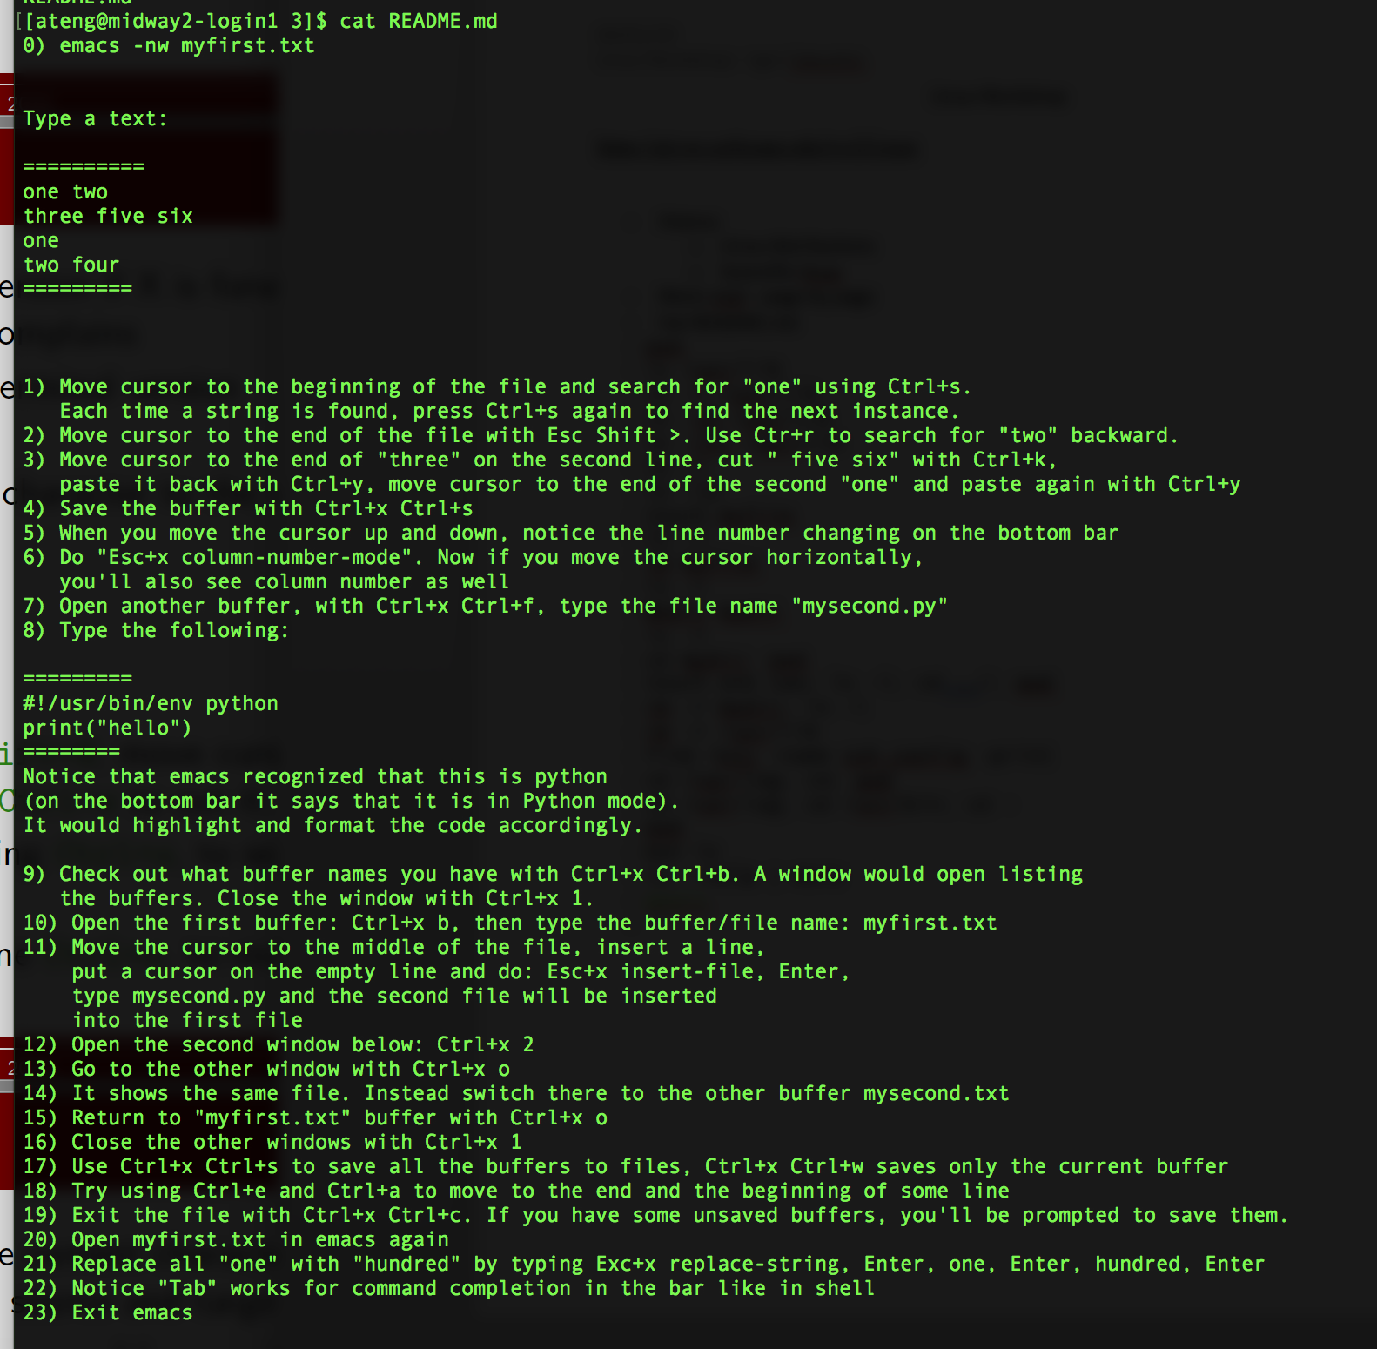

ls -l

# copy a file to your $HOME

# providing the target directory

cp linux.txt ~/

# providing the target file name

cp linux.txt ~/linux5.txt

# check that the files are there

ls -ltr $HOME/

# rename or move a file

mv ~/linux5.txt ~/linux6.txt

ls -ltr $HOME/

# If you have ssh client on your computer, try to use scp to copy some file

# from you laptop to midway:

scp <somefile> <username>@midway2.rcc.uchicago.edu:

or

scp <somefile> <username>@midway2.rcc.uchicago.edu:<somefile 1>

or

scp <somefile> <username>@midway2.rcc.uchicago.edu:/scratch/midway2/<username>/

# Try to copy directory:

scp -r <somedir> <username>@midway2.rcc.uchicago.edu:

# Try to use rsync if you have it:

rsync -av <somedir> <username>@midway2.rcc.uchicago.edu:/scratch/midway2/<username>/

# If you are on Mac/Windows, try to copy a text file to midway and check with cat -A

# if you have just $ at the end of each line, or ^M$

# In the latter case, run

dos2unix <yourfile>

and check again with

cat -A <yourfile>

the end of line character.

# Take a look at the provided files edited under Linux and Windows:

cat -A linux.txt

cat -A windows.txt

# If you do not yet have ssh/scp working, use JupyterHub to upload and download files

# ThinLinc does not support it.

[ateng@midway2-login1 4]$

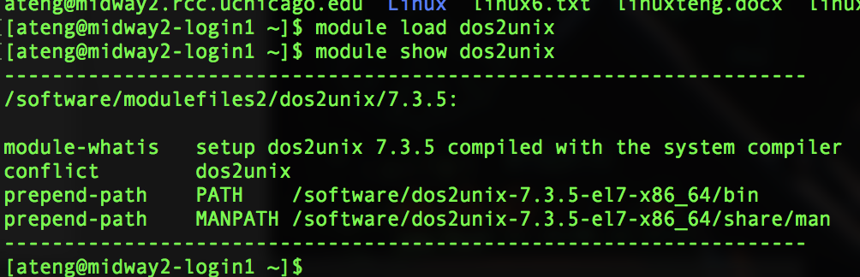

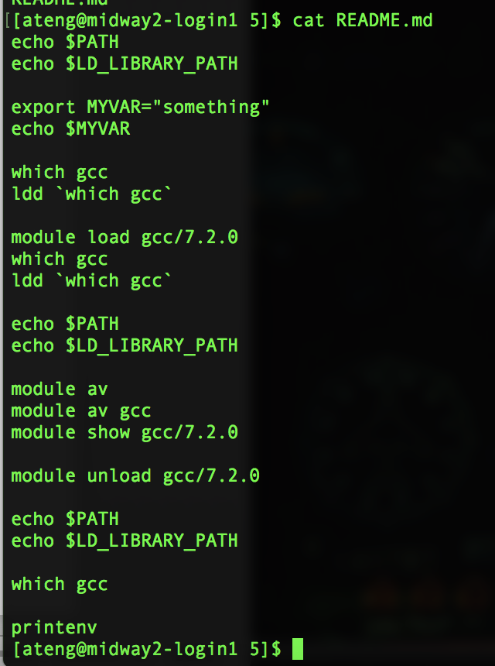

x